**Question:01**

**Code:**

#include<stdio.h>

void main (void){

char name[20],DOB[20],Mobile[20];

printf("Enter your name=\n");

scanf("%s",&name);

printf("Enter your date of birth=\n");

scanf("%s",&DOB);

printf("Enter your mobile number=\n");

scanf("%s",&Mobile);

printf("Name : %s\n",name);

printf("DOB : %s\n",DOB);

printf("Mobile : %s\n",Mobile);

}

**Output:** 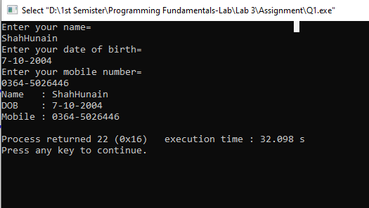

**Question:02**

**Code:**

#include<stdio.h>

int main (){

printf(" #####\n");

printf(" #\n");

printf(" #\n");

printf(" ####\n");

printf(" #\n");

printf(" #\n");

printf(" #\n");

printf("\n\n\n ###\n");

printf(" #\n");

printf(" #\n");

printf(" #\n");

printf(" #\n");

printf(" ###\n");

}

**Output:**

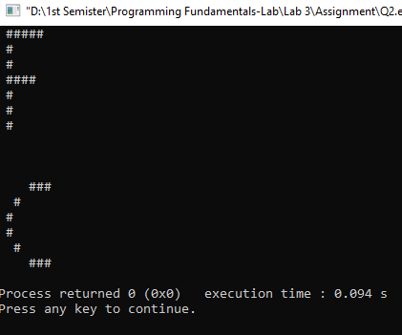

**Question:03**

**Code:**

#include<stdio.h>

void main (void){

char ch1[20],ch2[20],ch3[20];

printf("Enter the first letter=");

scanf("%s",&ch1);

printf("\nEnter the second letter=");

scanf("%s",&ch2);

printf("\nEnter the third letter=");

scanf("%s",&ch3);

printf("'%s','%s','%s'",ch3,ch2,ch1);

}

**Output:**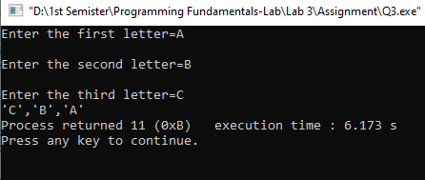

**Question:04**

**Code:**

#include<stdio.h>

#include<conio.h>

void main (void){

int var1,var2,sum;

var1=var2=sum=0;

printf("Enter the first integer\n");

scanf("%d", &var1);

printf("Enter the second integer\n");

scanf("%d", &var2);

sum=var1+var2;

printf("Sum of the above two integers is= %d\n",sum);

}

**Output:**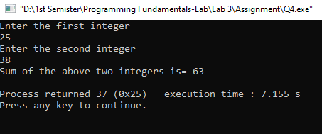

**Question:05**

**Code:**

#include<stdio.h>

#include<conio.h>

void main (void){

float weight1,weight2,numberof1st,numberof2nd,avgvalue,totalitems,finalavgvalue;

weight1=weight2=numberof1st=numberof2nd=avgvalue=totalitems=finalavgvalue=0;

printf("Enter the weight of 1st item\n");

scanf("%f", &weight1);

printf("Enter the number of 1st item\n");

scanf("%f", &numberof1st);

printf("Enter the weight of 2nd item\n");

scanf("%f", &weight2);

printf("Enter the weight of 1st item\n");

scanf("%f", &numberof2nd);

totalitems=numberof1st+numberof2nd;

avgvalue=numberof1st*weight1+numberof2nd*weight2;

finalavgvalue=avgvalue/totalitems;

printf("Average Value= %.6f",finalavgvalue);

}

**Output:**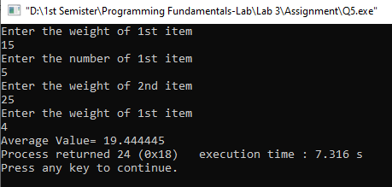

**Question:06**

**Code:**

#include<stdio.h>

#include<conio.h>

void main (void){

int hours,minutes,seconds;

hours=minutes=seconds;

printf("Enter the integer=\n");

scanf("%d",&seconds);

hours=seconds/3600;

minutes=hours*60;

printf("There are:\nH:M:S-%d:%d:%d\n",hours,minutes,seconds);

}

**Output:**